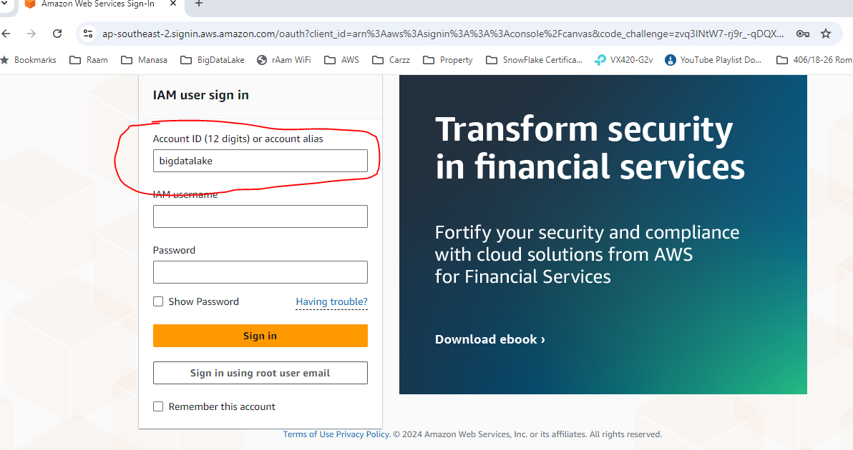

See the login.txt and login as the ‘root’ user

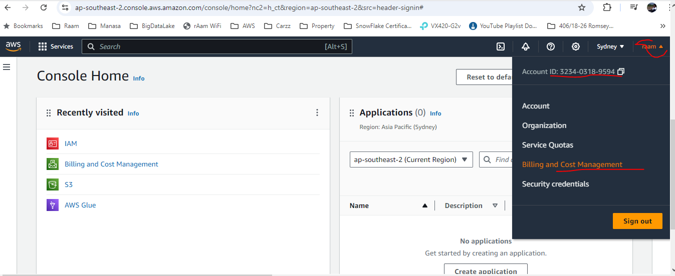

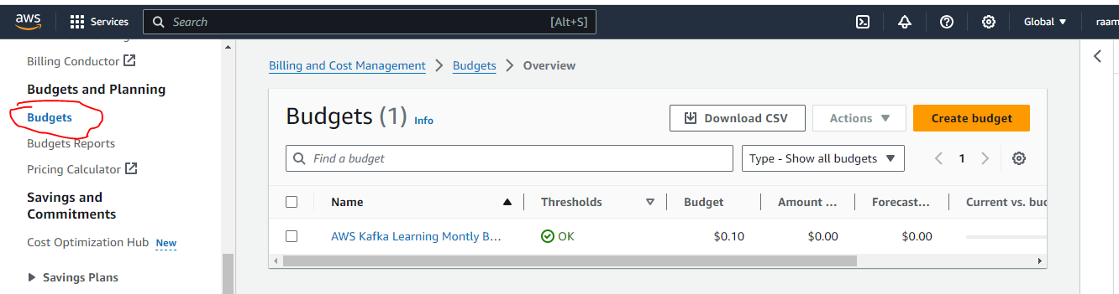

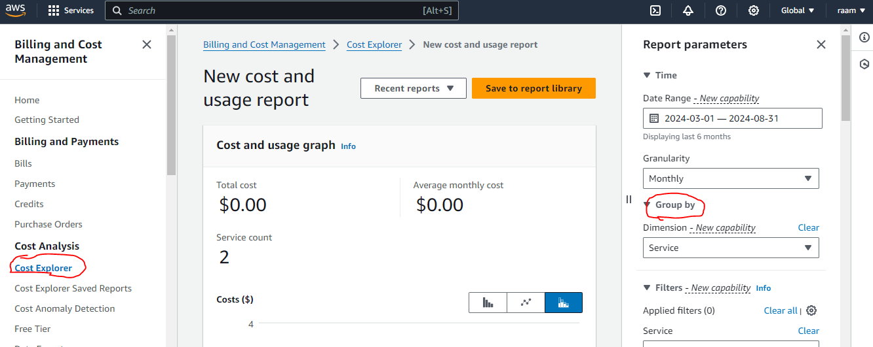

1. AWS CLI - Accessing AWS Service using Cmd Line Interface

* AWS CLI is used to run aws cmds using the credentials we configured locally.
* Install the AWS CLI first using *pip*

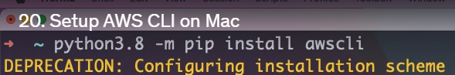

* Check the AWS

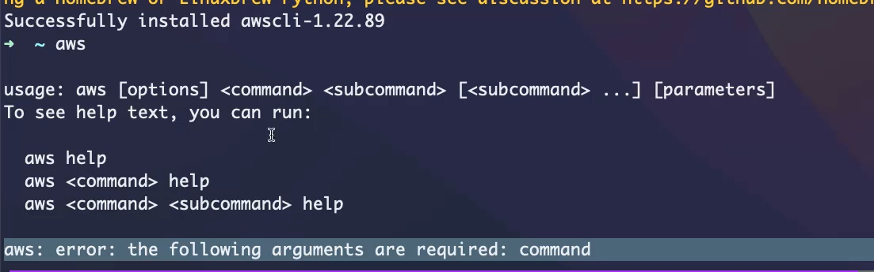

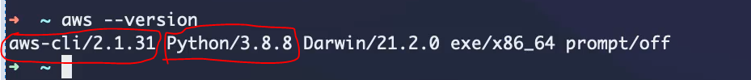

Cli version is 2.1.31 using Python3.8.8

* Lets configure the CLI using a new IAM USER, access key and secret key for that user

New IAM User :

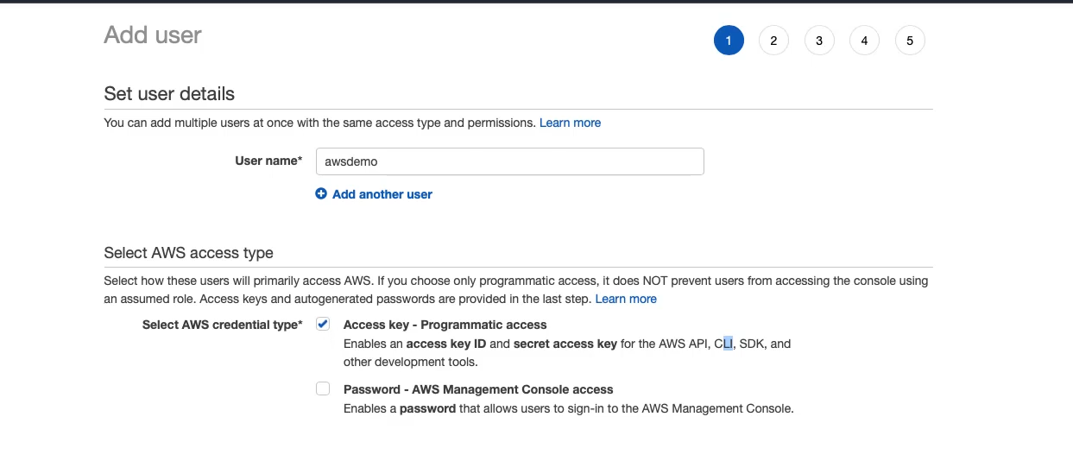

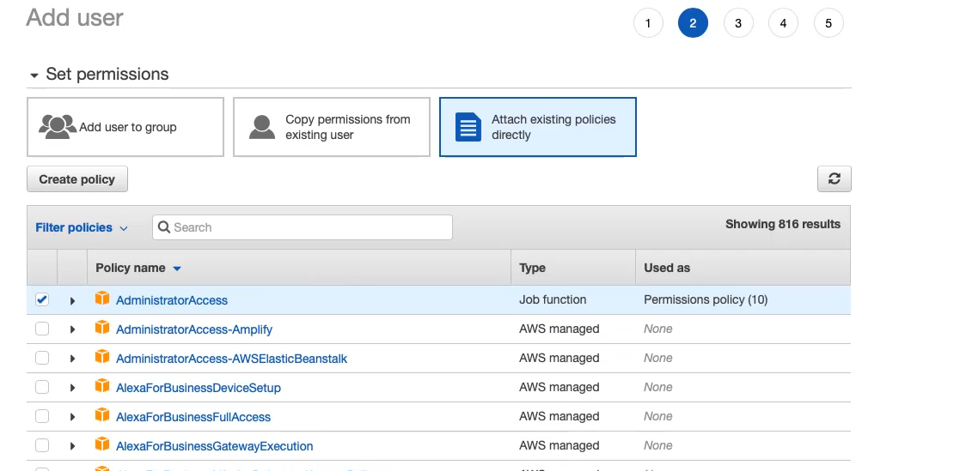

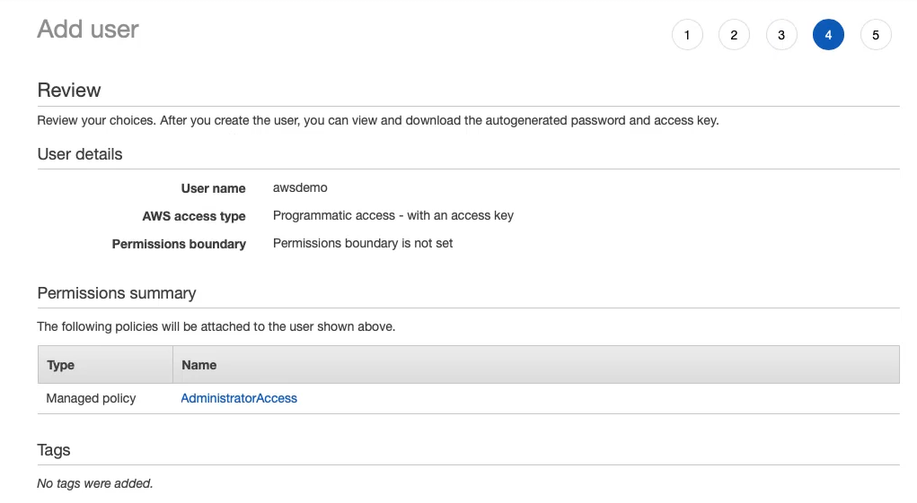

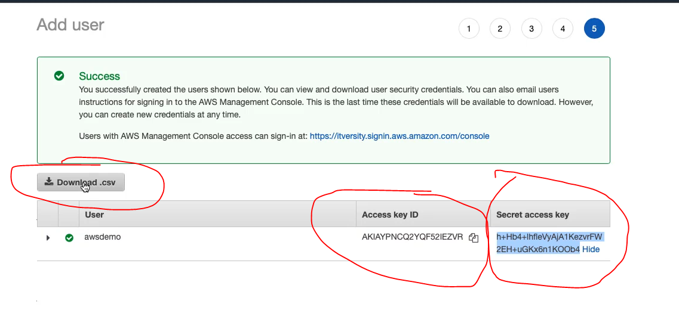

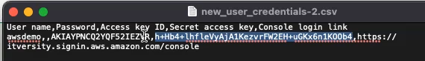

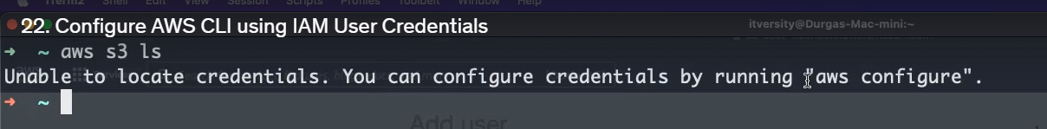

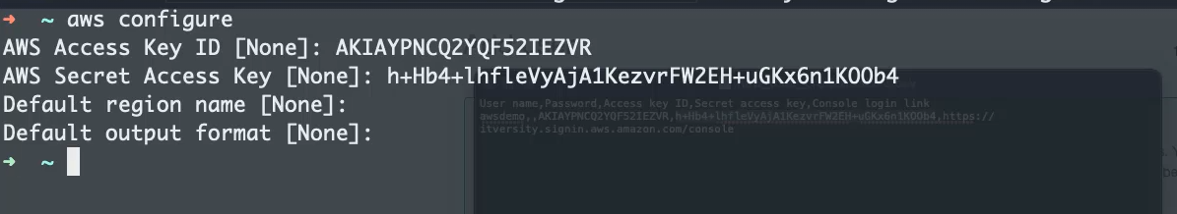

* Under the home directory, there will a hidden directory called .aws, which stores this credentials

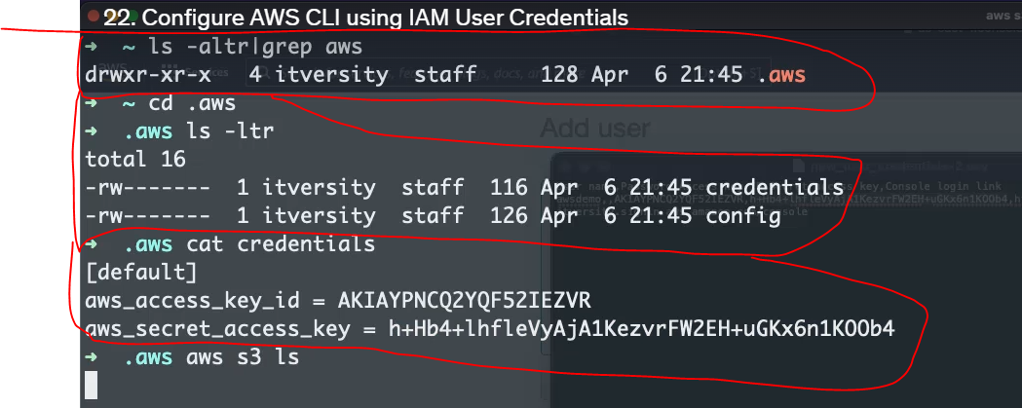

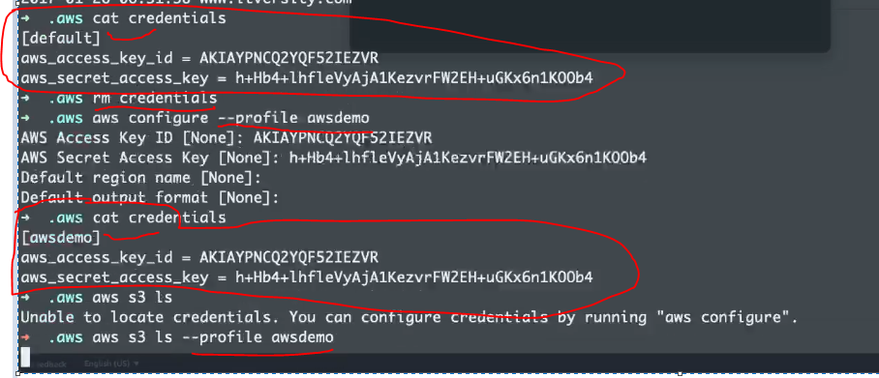

1. Boto3 : Access AWS Services using Python Based SDK – BOTO3

* Set up the python virtual env first.

*cd /user/vuppupra/virtualEnv*

*python3.12 -m venv dev-local-venv*

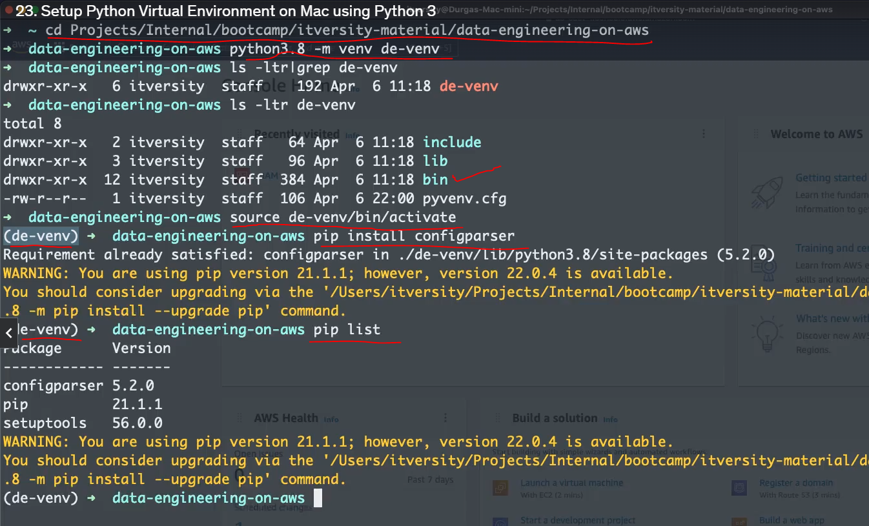

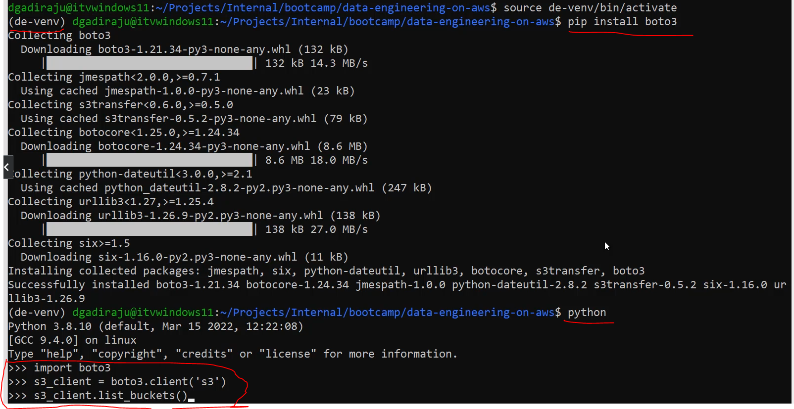

* Install jupyterlab in the same virtual environment



* Launch the jupyterlab



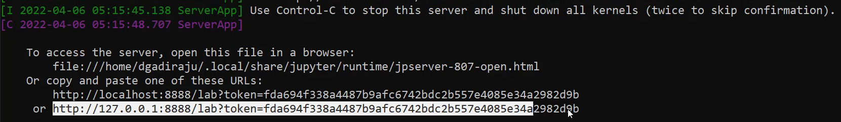

* Able to access due to the **default** profile in the aws cli config

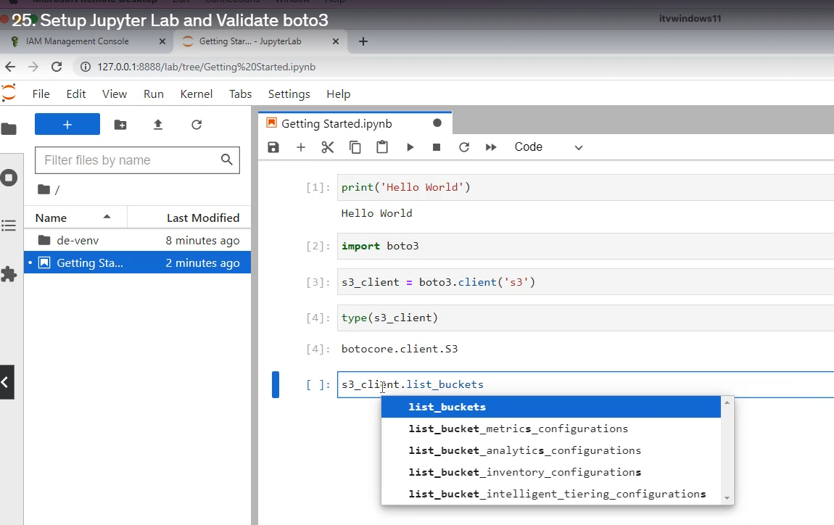



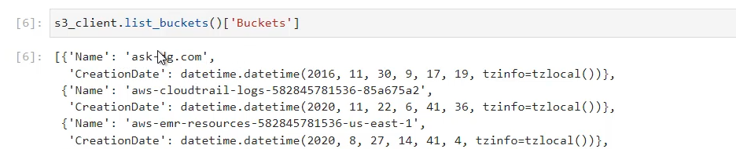

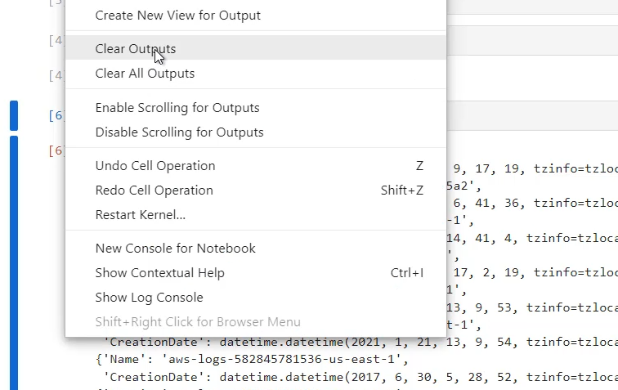

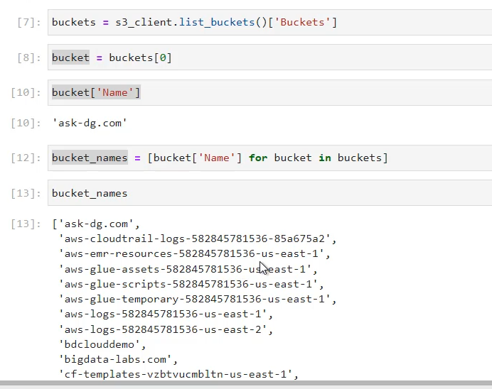

**Note :** *bucket[‘Name’]* as it is a dict type, will fetch the corresponding value to this key

1. Cloud9 : Official AWS IDE

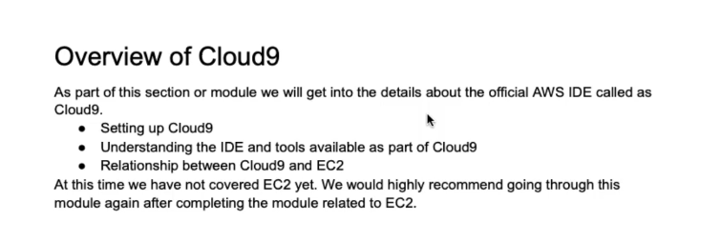

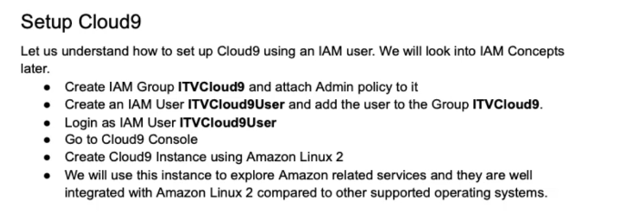

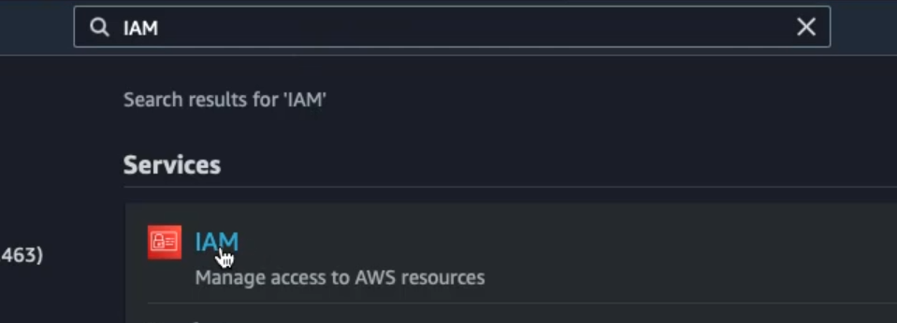

* Create a new group

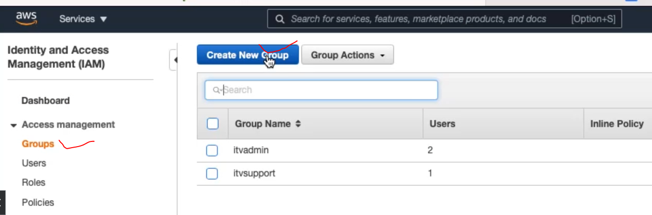

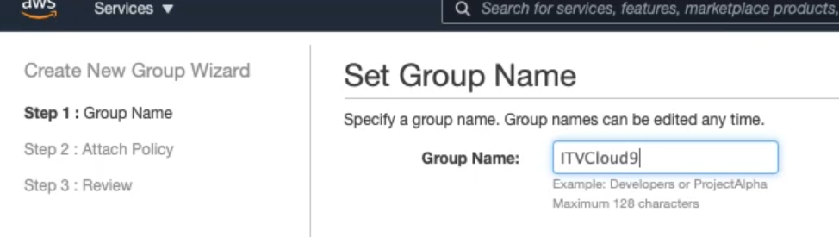

* Attach a policy to this new group. Now all the user for this group will have Administrator access

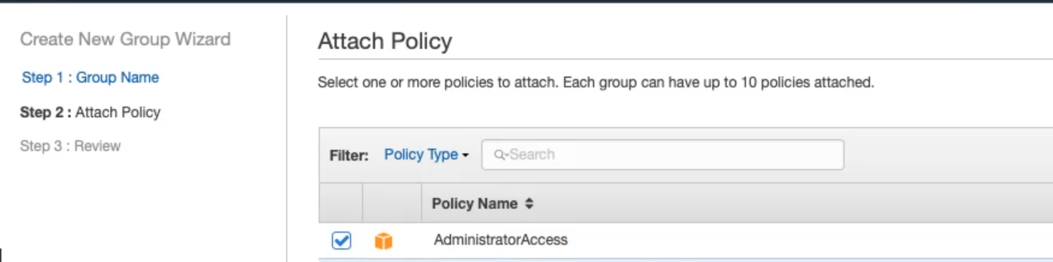

* Add a user for this group

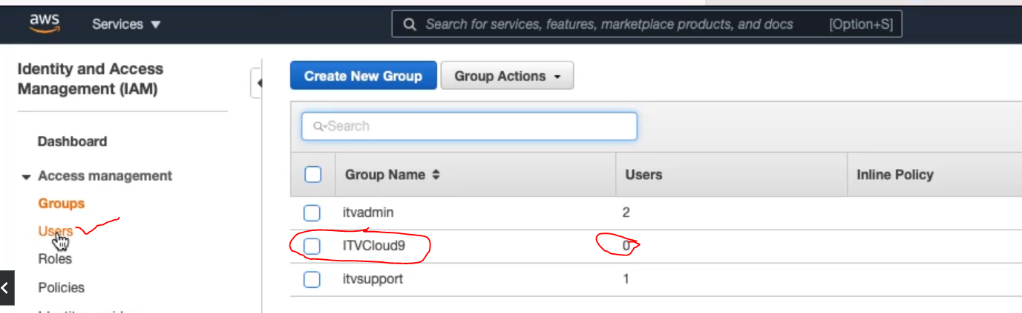

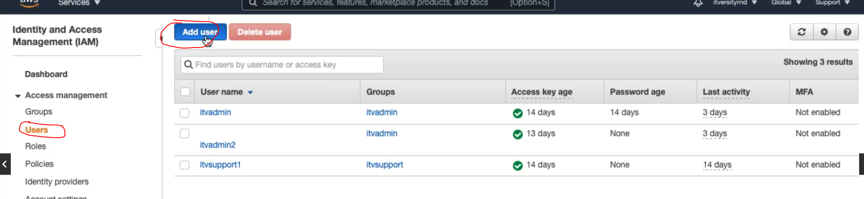

* For this user, lets give both ‘Programmatic’ & ‘Console’ ACCESS

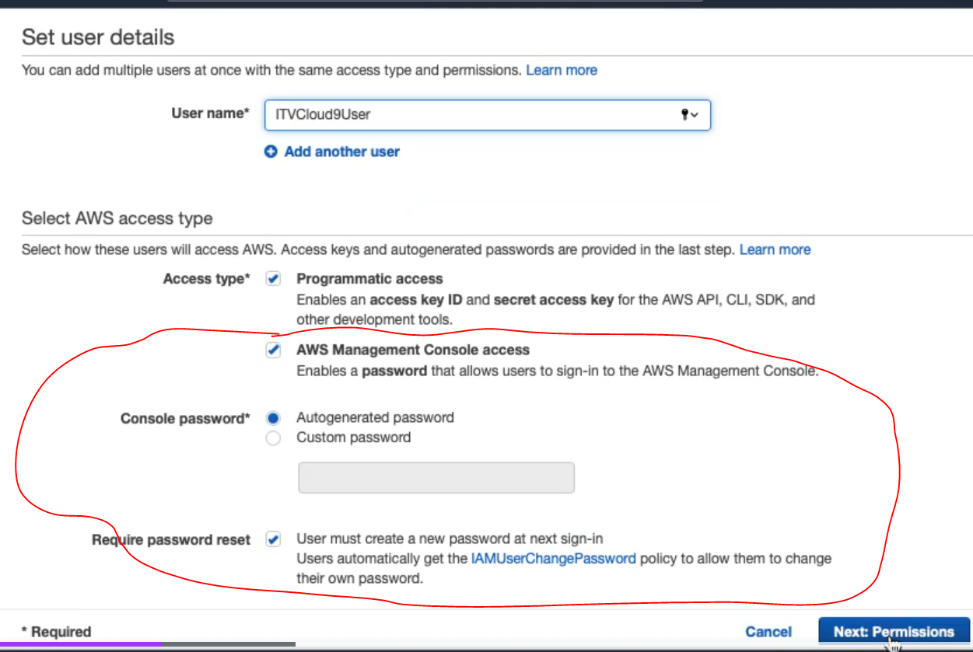

* Associate this user to the above group, instead of adding a policy

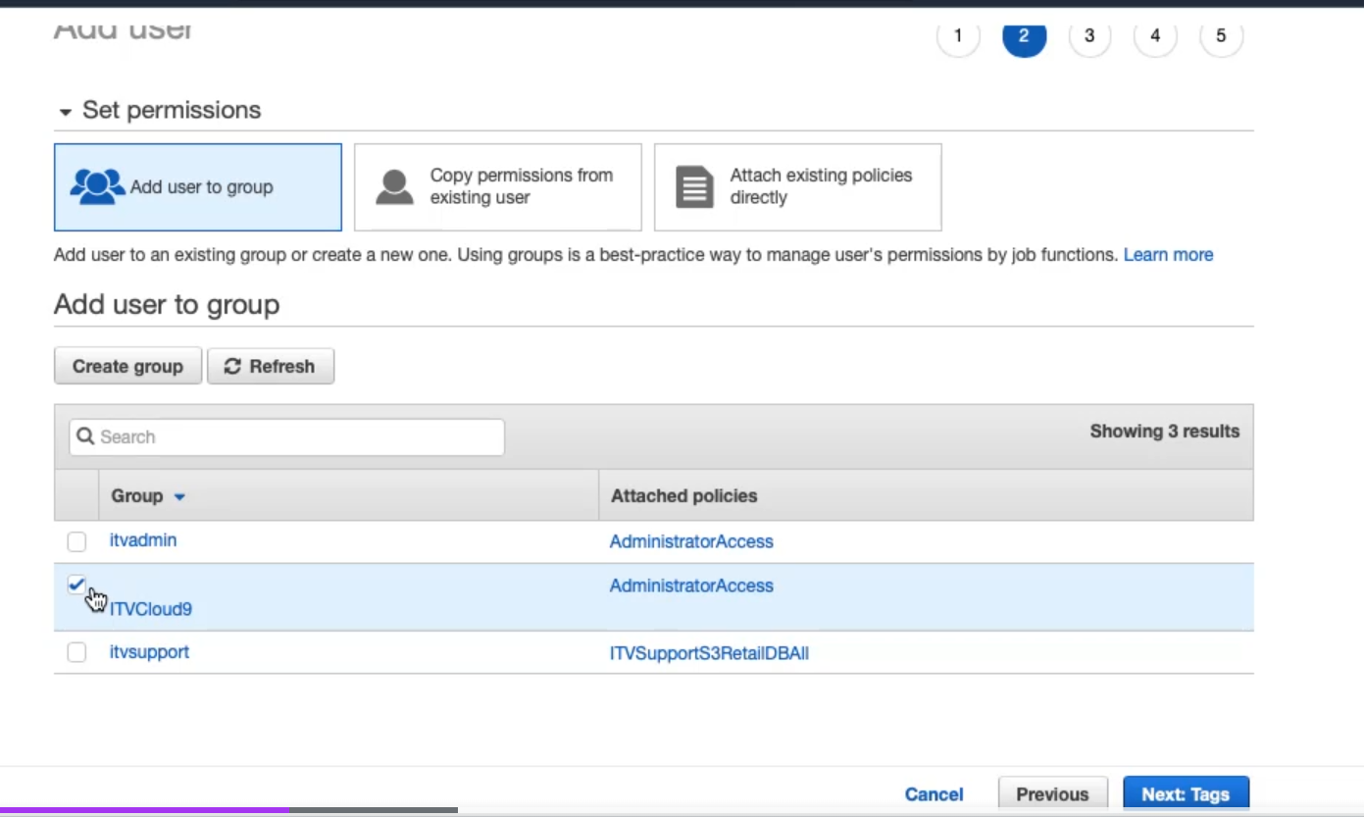

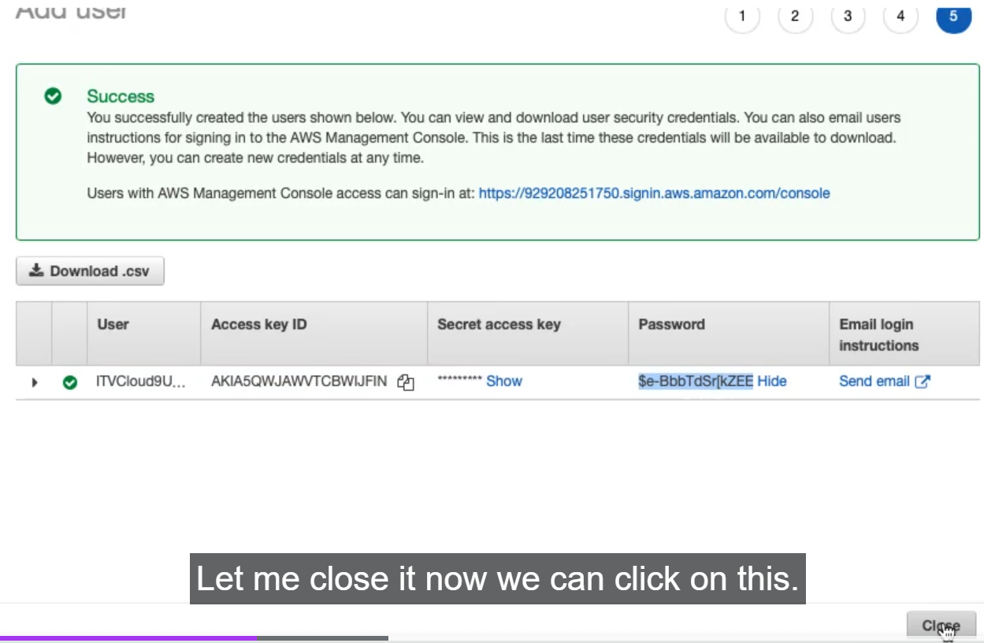

* Now Click on the user ‘ITVCloud9User

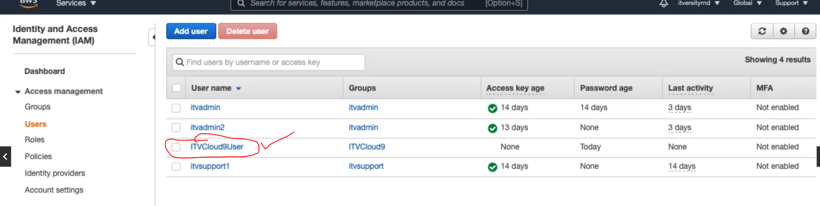

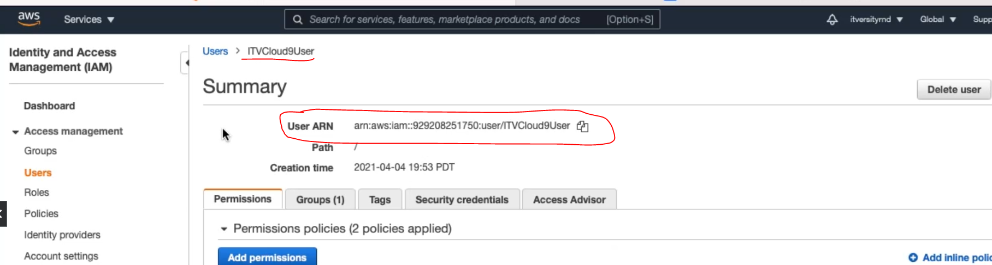

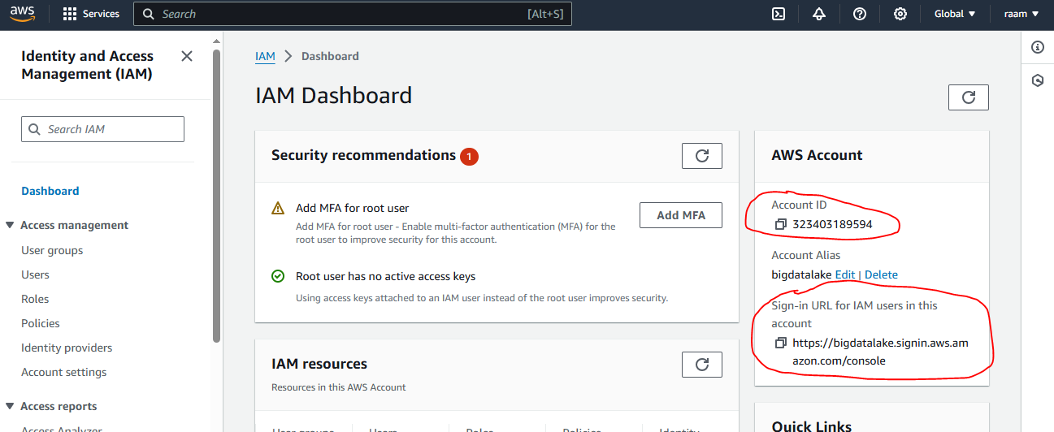

* Now login with that new IAM User

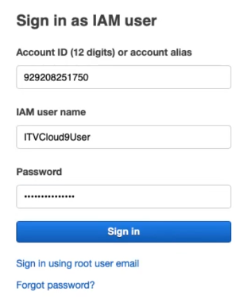

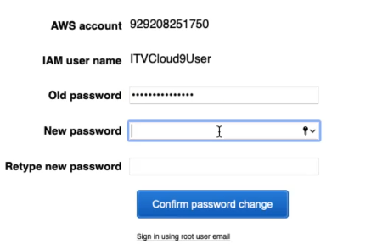

**Note :** highly recommended to not to create cloud9 instances using root account, we should be using IAM user accounts.

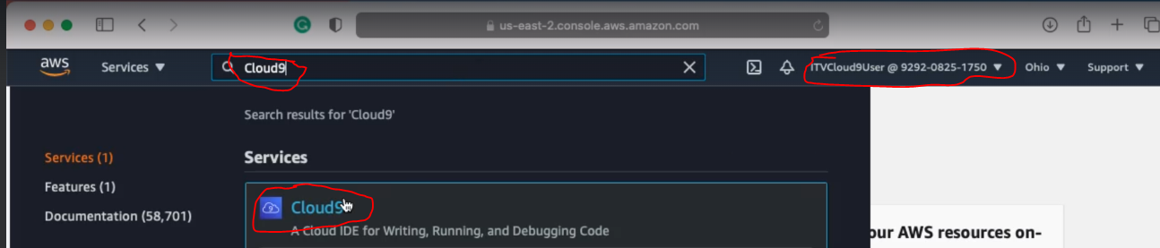

* Create a new Cloud9 env

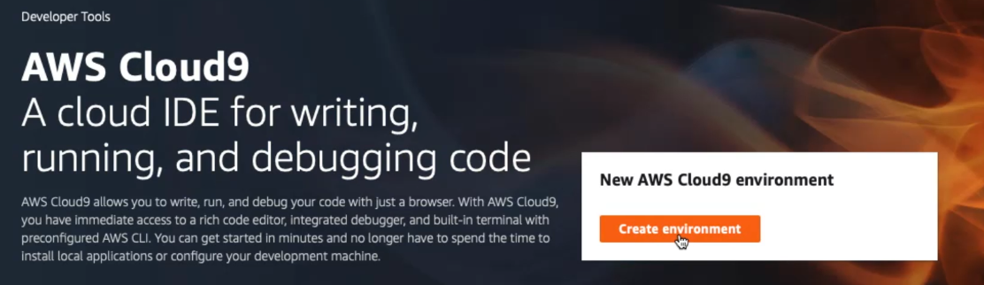

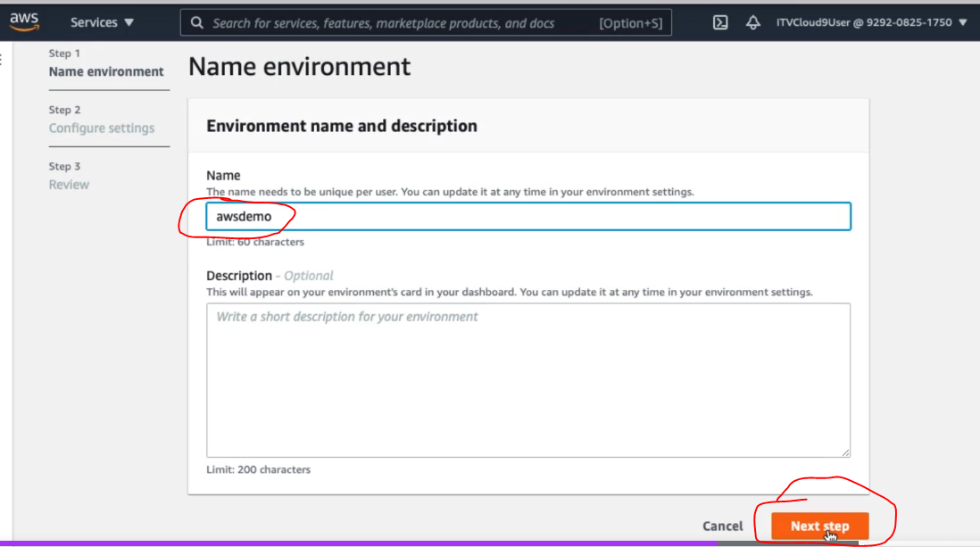

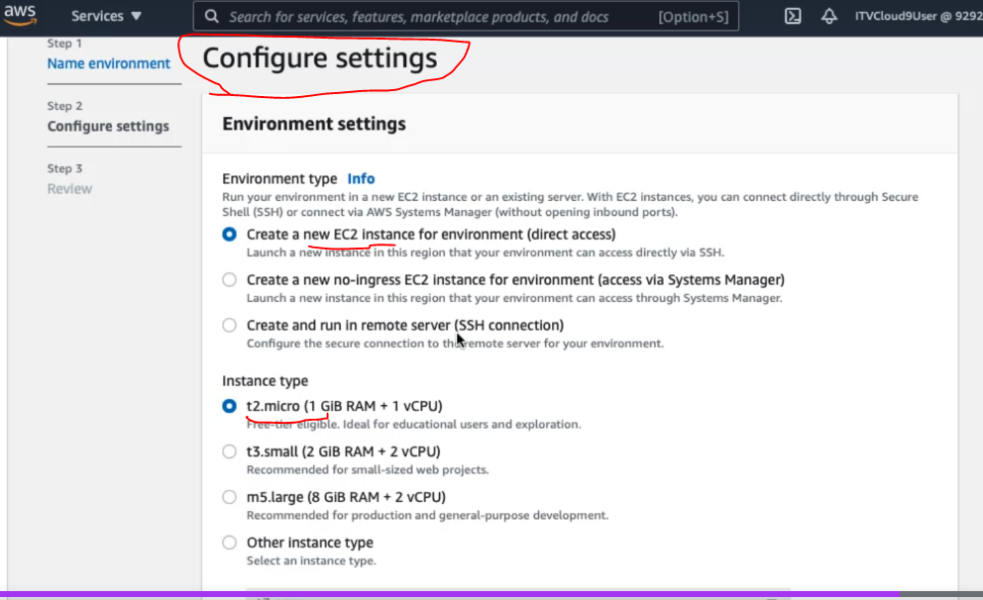

Amazon Linux2 is recommended for AWS Native Applications.

Stops EC2 associated with Cloud9, after 30 mins of inactivity

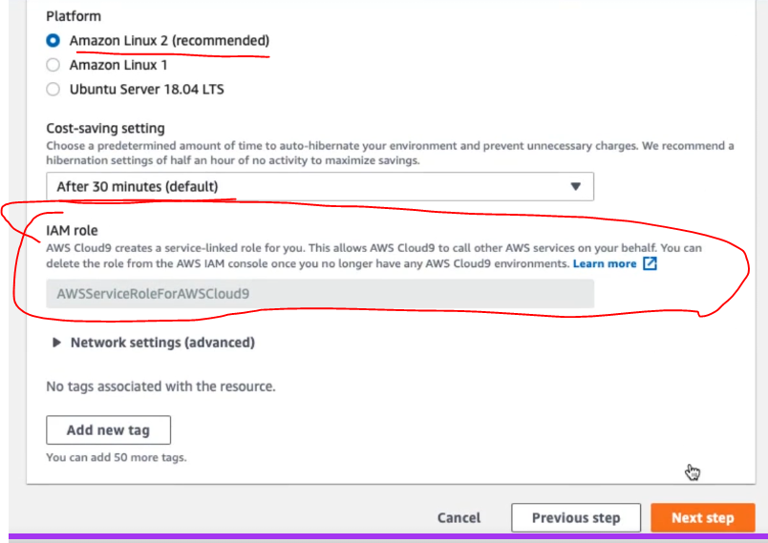

Cloud9 IDE is ready as below :

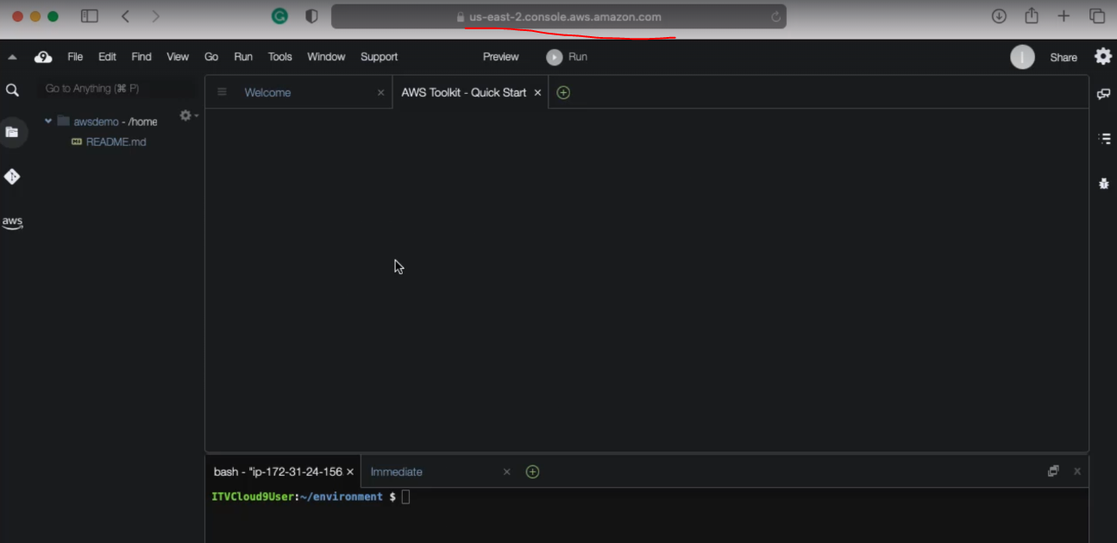

* Add a new terminal as below

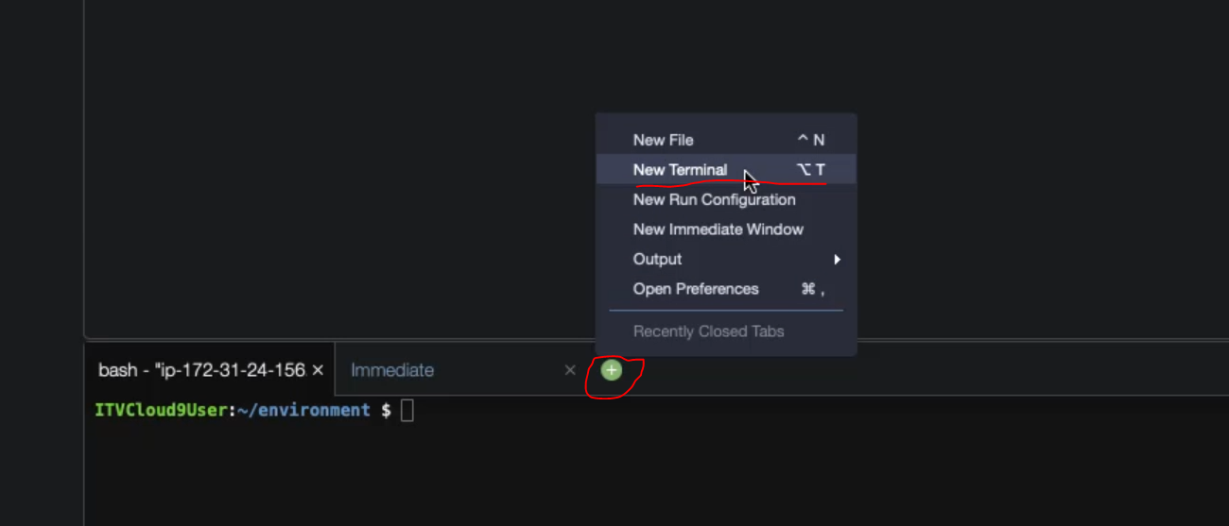

* To Increase the font size in the terminal

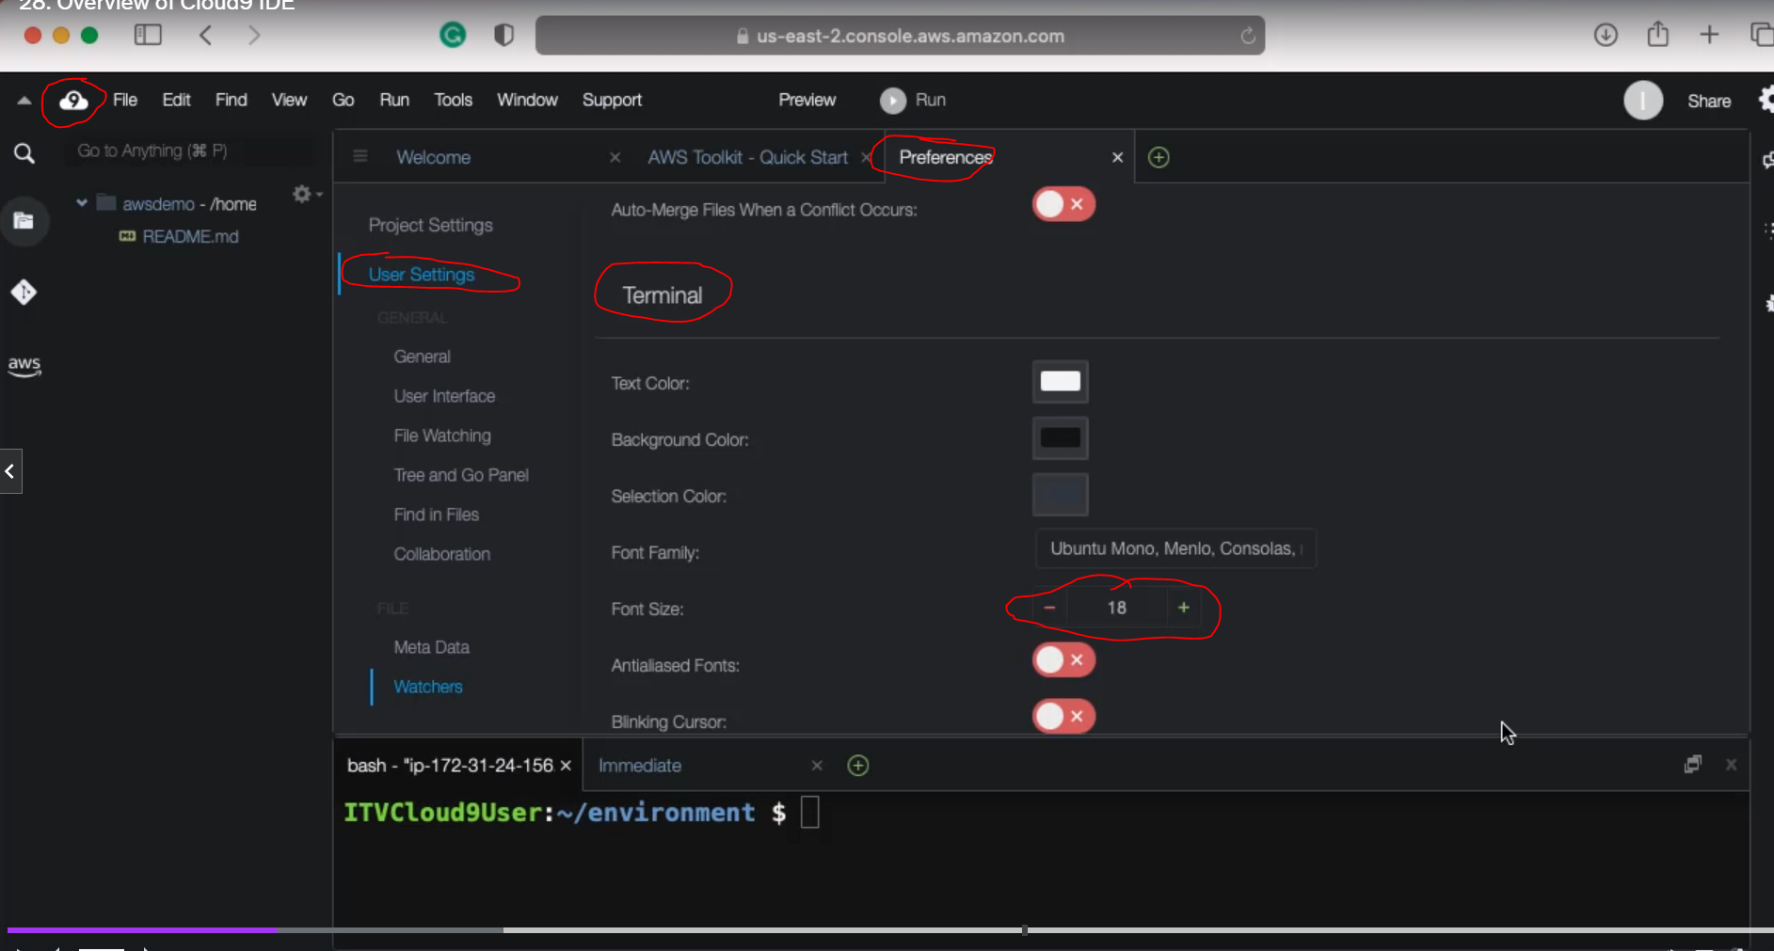

* Create a new python file, which will be stored on the ec2 instance itself

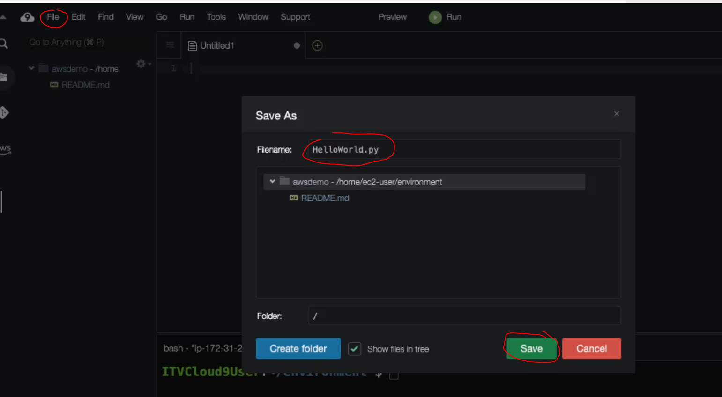

* Expand the terminal and check if *git, docker, httpd* are installed on ec2 instance

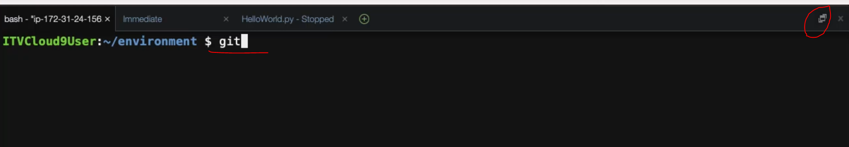

*‘docker ps’* to list any docker containers



*sudo systemctl status httpd* 🡪 to check the HTTP Server demon status



* Check the python versions installed. Type ‘python’ and hit tab twice to see the below

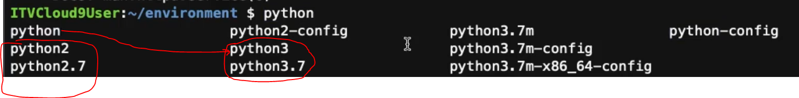

python2 is an alias to python2.7

python3 is an alias to python3.7

And python is an alias to python3.7 itself

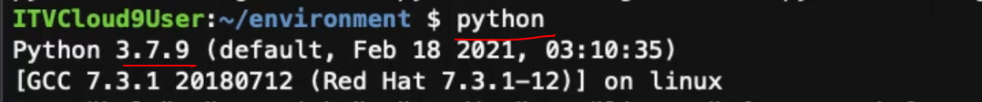

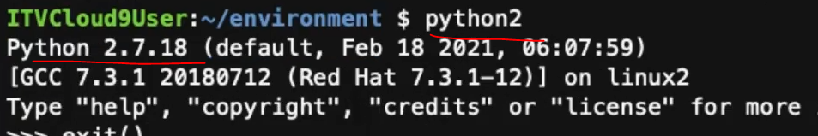

* Check the Java Version

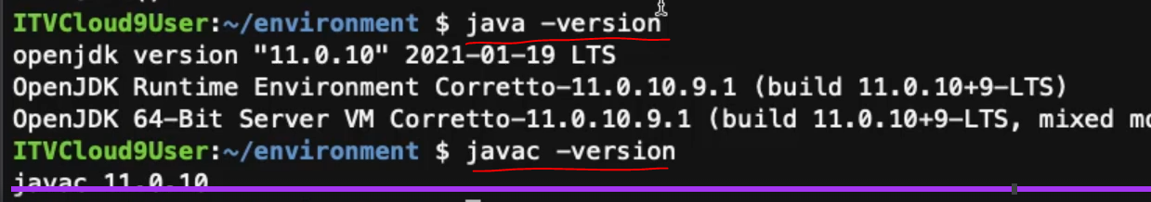

*ITVCloud9* user inherits the permissions of this policy called as '*AdministrativeAccess*', which means the user have complete control on it.

To check this, run the below ***AWS CLI*** command on the Cloud9 Terminal.

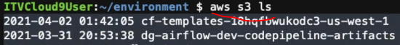

Test the docker, to run hello world it will actually pull the *Helloworld image*. It will just print Hello World and the container will be stopped automatically.

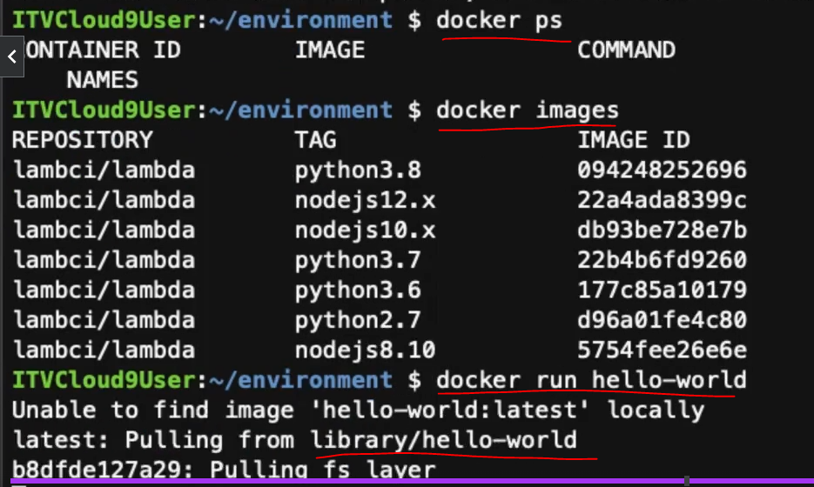



Now check the containers as below

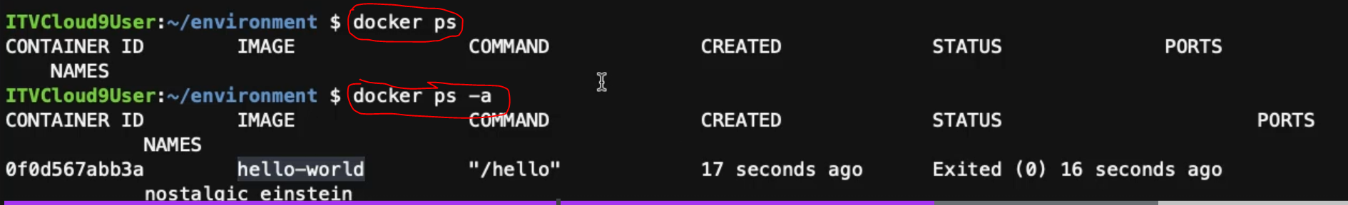

Now check the images which will have the hello-world image

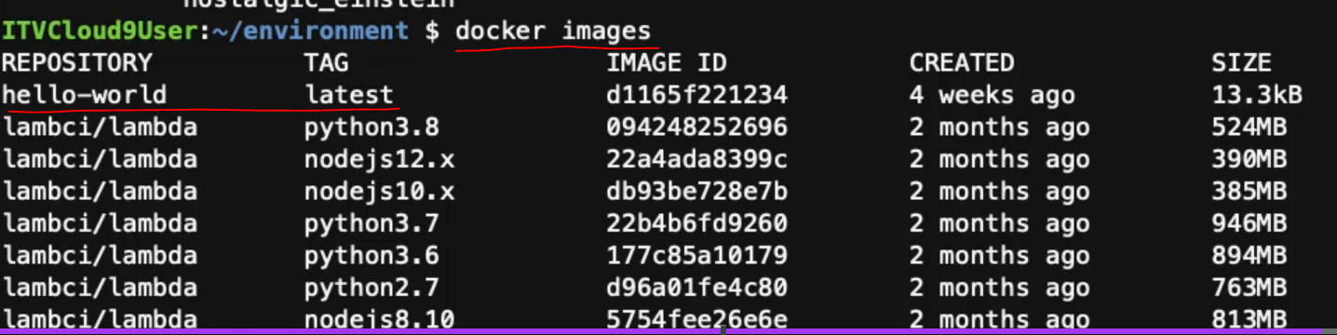

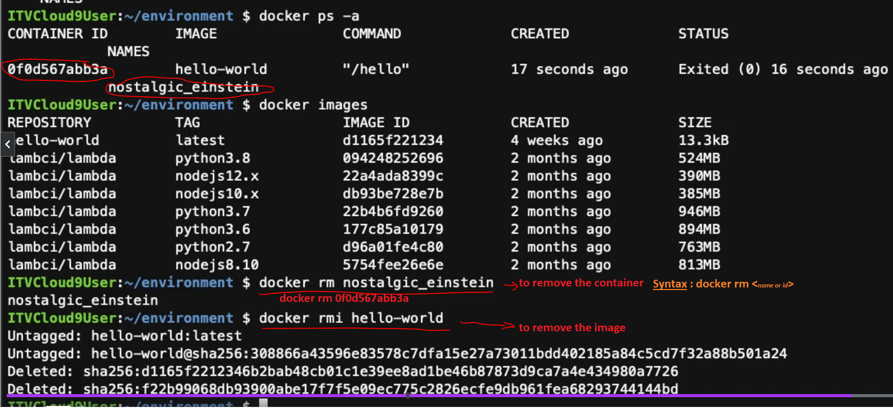

1. Cloud9 & EC2 – Relationship:

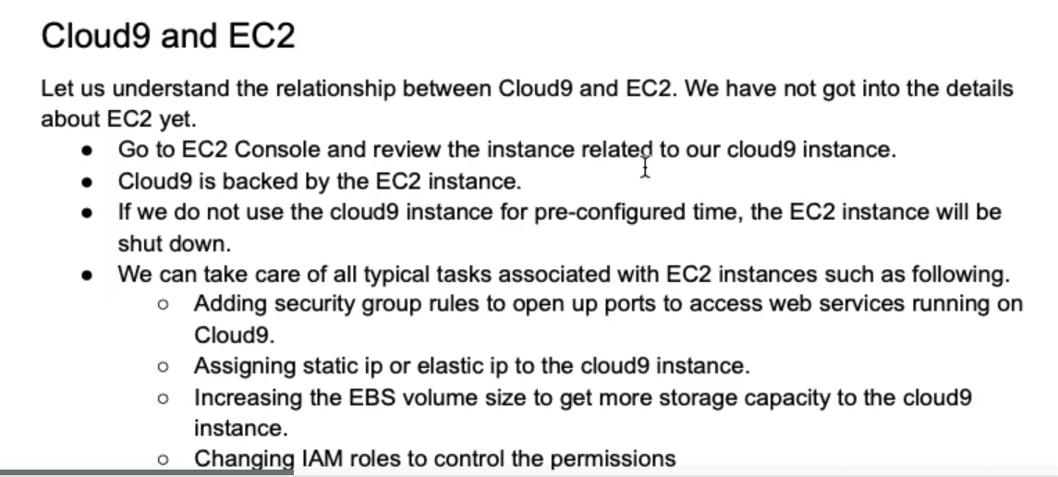

* Goto cloud9 UI or EC2 UI and look for the EC2 instance which is running.
* From the cloud9 UI as below

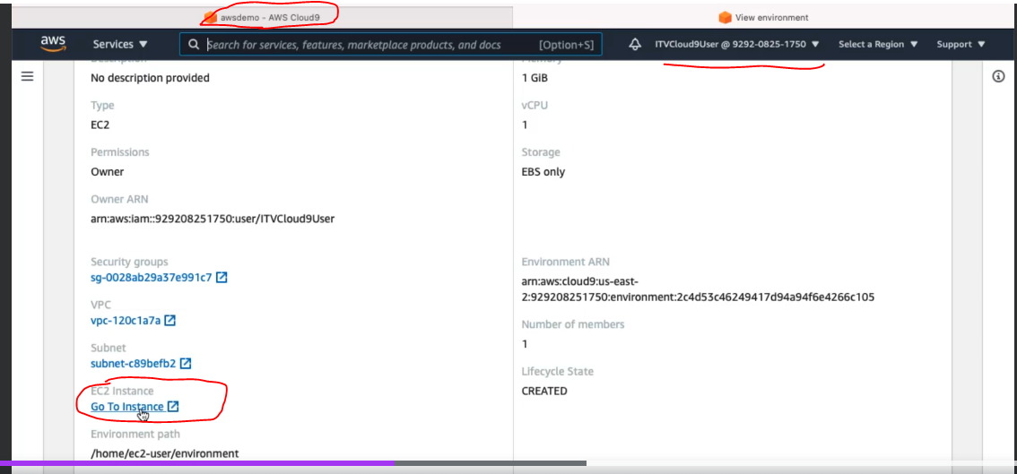

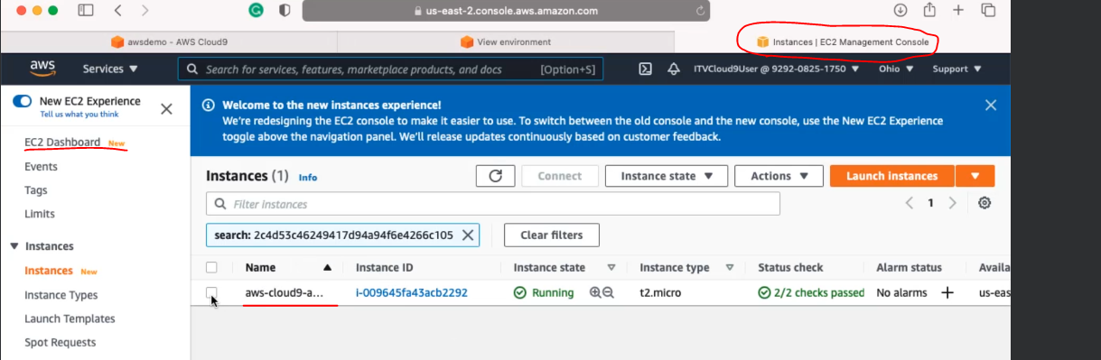

Access the Web Applications running on the EC2 instance

* First check whether HTTP server is up & running or not. If not then start it

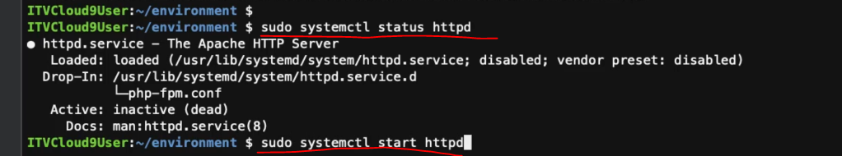

* Now check the status again

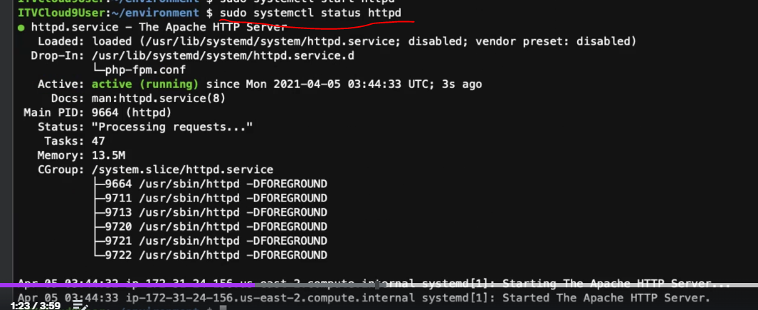

Telnet is typically used to validate whether we are able to listen to the web service that is running on a particular server on a particular port.

* Install the telnet in the EC2 as below



* 'telnet localhost 80' to confirm whether we are able to listen to http server that is running on this machine from the localhost itself,which means the webservice is accessible locally.

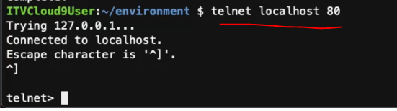

* However, if we use the public DNS, related to this EC2 instance. We can get the EC2's 'public DNS' and access it from web browser.

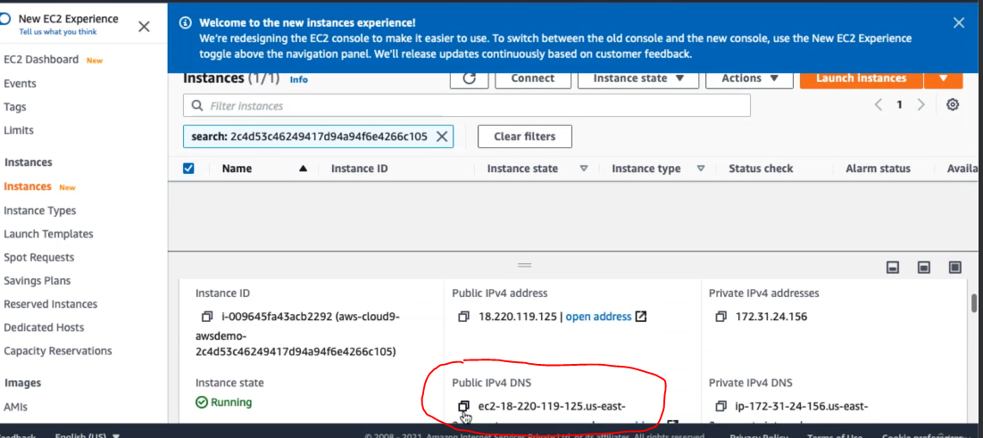

* Paste the above to browser and can see it’s not accessible



* To fix this, we have to open up the ports by going to the *‘Security groups’* associated with the EC2 instance.

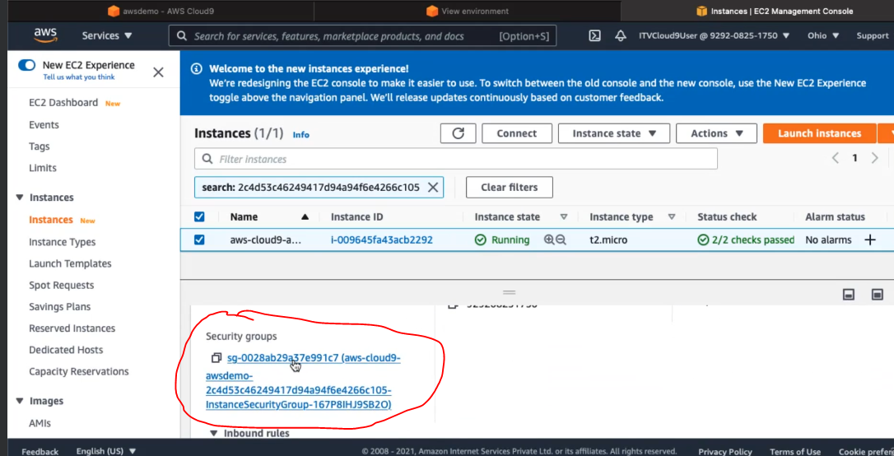

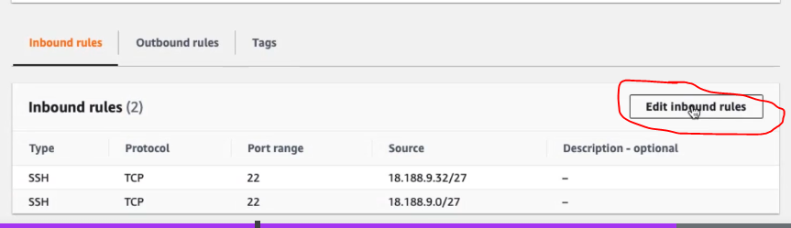

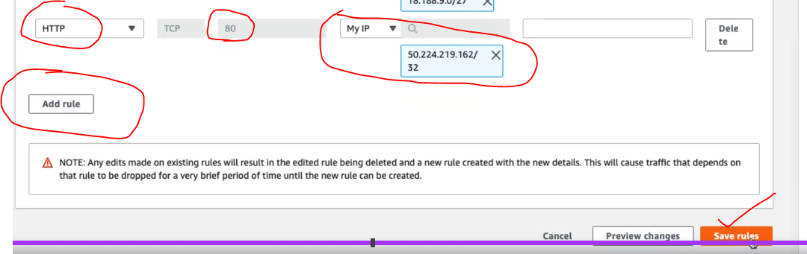

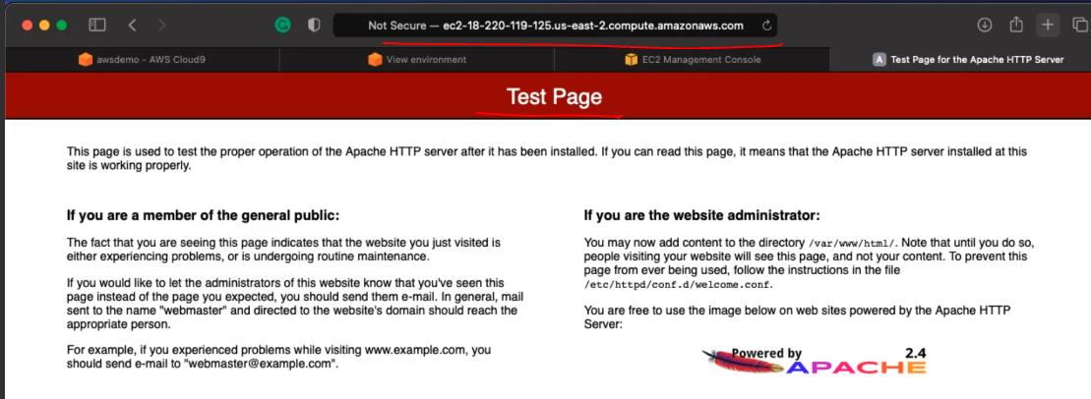

Static IP to EC2 Instance

* When a cloud9 instance is stopped and then resumed it will get a new public IP address and DNS alias as the public IP addresses are by default ephemeral. Ephemeral means they will cease to exist once the EC2 instance is stopped.

Step-1 : see the ‘address’ & ‘DNS’ as below for the current running instance

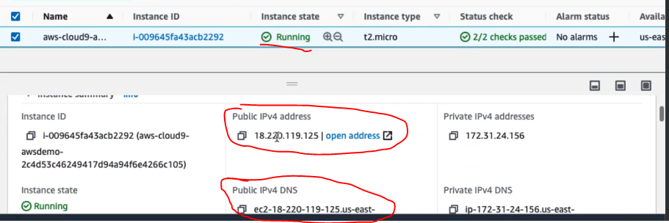

Step-2 : Now stop the instance

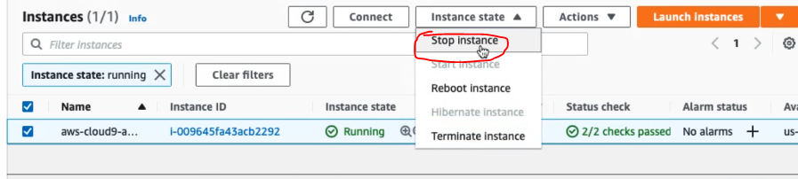

Step-3 : Let's wait until this is completely stopped as we are not ideal for 30 minutes. It will be started immediately, but you will see new IP address and also the DNS.

Now it is stopped. it will come up in a moment.Once it comes up, you will see a new IP address as well as the DNS.

